11th September – The day that changed the future

Introduction
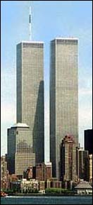
Before I start I’d like to make it very clear that what happened that horrendous day was very bad and completely unnecessary. Although I personally think that, I’ve tried to write from all kinds of different perspectives so that the reader can decide by him/her self what the “truth” behind this incident is. Also I’ve come to learn that things aren’t what they appears to be and that you should check all sources carefully because there are people on the web who just loves to mislead people. For example I found a lot of sites that were talking down about Muslims and also Jews. And it just hurts me to know that there are so many people who don’t want the truth to come out.

Course of events
An American Airlines Boeing 767 and a United Airlines Boeing 767, both on a route from Boston to Los Angeles, were hijacked and flown only minutes apart into the towers of the World Trade Center in New York City. Shortly afterward, an American Airlines Boeing 757, on route from Washington, DC, to Los Angeles, crashed into the Pentagon. A fourth hijacked plane, operated by United and headed from Newark to San Francisco, crashed in a field near Shanksville, Pa. Both World Trade Center towers collapsed, and a section of the Pentagon was destroyed. All 266 people aboard the planes were killed; the total number of dead and missing was 3,038 (including the 19 hijackers). The names of the hijackers, Islamic radicals part of the al-Qaeda terrorist organization, were released a few days after the attacks.

WTC before9/11

8:45 A.M.—American Airlines Flight 11, Boston to Los Angeles, with 92 people aboard, crashes into the north tower of the World Trade Center in New York City.
9:03 A.M.—United Airlines Flight 175, Boston to Los Angeles, with 65 people aboard, flies into the south tower of the World Trade Center.
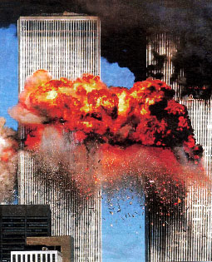
9:40 A.M.—American Flight 77, Washington, DC, to Los Angeles, with 64 people aboard, crashes into the Pentagon.
9:48 A.M.—The U.S. Capitol and the West Wing of the White House are evacuated.
9:49 A.M.—The Federal Aviation Administration orders all aircraft grounded in the United States.
9:50 A.M.—South tower of the World Trade Center collapses.
9:58 A.M.—Emergency operator in Pennsylvania receives a call from a passenger on United Flight 93; Newark to San Francisco, with 45 people aboard, stating the plane was being hijacked.

WTC after the first plane
10:00 A.M.—United Flight 93 crashes about 80 mi southeast of Pittsburgh. Passengers apparently attempted to overpower the hijackers, who were heading the plane toward Washington, DC.
10:29 A.M.—North tower of the World Trade Center collapses.
5:20 P.M.—Another World Trade Center building collapses…

W Bush and his administration before 9/11
When this event occurred President George W. Bush had been on his post for almost a year. On his first year he had spent the majority of his time at different holiday resorts, in Florida visiting his brother or playing golf. He really didn’t do much and the outside world didn’t really care about him, although there were some protests against him. mostly against his way of handling environmental issues. An example is the Gothenburg demonstration. We all know what happened there…

Nevertheless things around the world were relatively calm and W Bush didn’t do much. In fact he didn’t even react when he got the news of the first airplane hijacking. He just sat and pretended that nothing was wrong. As the attack took place Bush was on his way to an elementary school in Florida. When informed of the first plane hitting the World Trade Center, where by the way terrorists had struck just eight years earlier, Bush just decided to go ahead with his photo opportunity. Perhaps he was in the state of chock; perhaps he was reflecting on what his next move would be, no one will ever know (unless he writes an autobiography). Whatever the reason was, his actions the fallowing hours after the first plane crashed was definitely not the smartest.

W Bush and his administration after 9/11
A day after, the 12th, he kept a speech to the world and to America. A speech where he used phrases like “dead or alive” and “with or against us”. Hardly the way you’d expect one of the most powerful men in the world to speak.
Many world leaders, and also leading Americans, criticized him for the way he was handling the situation. Jimmy Carter, a former President, had a lot to say about how he could have dealt with the situation in a better way.

After his “great” speech to the nation he did his best to find someone who would take responsibility for the actions. The name landed upon the very well established terrorist organisation al Qaeda. But there are debates going on still about whether or not they actually was behind 9/11 since they never really took responsibility for what happened. However they where the ones, who the American government said, where entirely to blame.

So in the chase of the highest al Qaeda leaders and other members of this organisation, the Bush administration began to search all countries. From Afghanistan to Sweden. They had complete access to all personal files and also all personal secure bank accounts.

After their little global investigation of all people with some sort of connection to al Qaeda, they came out in public and ancones that the master brain (Osama bin-Laden) is hidden somewhere in Afghanistan near the Torah Bora area. The hunts for him and his men begin and Bush goes in with his army and actually starts a war just to find some people. Doesn’t make any sense really. Not for us, neither it did for the UN. But in spite of demonstrations and criticism from fellow Americans and also other countries leaders, the bush administration didn’t care for them and just ignored. Though they felt, as it was their God given right to kill others as they had been killed.

The CIA conspiracy theory
This may sound a little odd but try to just see this from others perspective.
Some say, and there are quite a lot of them, who claims that the September 11 incident in fact was planed by the CIA to make up an excuse to raise the security all over the country. This lead to increased power for the leading CIA agents. Another reason is that the CIA needed funding. By this attack on US, the people and government turned to their most “reliable” security source, the CIA.
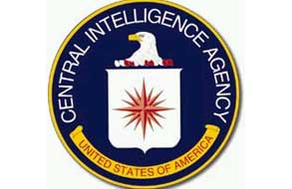
They got missions to take care of the Middle East situation and the suppressors they were living under. Many say that because of these disturbances in the world, people have “forgotten” about the CIA and this have lead to them getting more space and being able to infiltrate different governments more easily.

Examples o earlier governmental infiltrations and missions are among others Mosaddeq (Iraq), Jacobo Arbenz (Guatemala) Salvador Allende (Chile). These are only the most ell know successful missions. People say that these wars in both Afghanistan and Iraq, which are a consequence of the 9/11, are missions to occupy Middle East countries. But no one knows for sure, as it is very hard to find any real evidence of this plans existence.

The CIA logo

This theory is quite popular actually. A rather high amount of people are critical to the CIA and they believe that even thought CIA might not have had direct connections to 9/11, they certainly had something to do with it and they definitely gained power by this happening.

The Jewish conspiracy theory
This is a theory that is well spread in the middle east where there already is established some sort of disliking between the Jewish community and the Muslims.
It’s also the theory that is most likely to be just paranoid mumbo-jumbo.

So this conspiracy is based on believes that the Jewish-Israeli government made up a plan to destroy the World Trade Centre and then blame the Muslims. This is also the “truth” terrorists tell their members to “motivate” them. The prove supporters of this theory claim that hey have are very abstract. For example they say that the day for this event, all Jews wee on holiday. That’s a rumour that that doesn’t hold as evidence, because so many people with Jewish or Israeli origin where killed among all other victims of the 9/11 attack.

But the strongest “argument” the follower of this theory hold is that the Israeli government has gained a lot of power since 9/11. And that is partly true. Because they have in fact strengthen their positions on the west bank since that day and they have also started to build a great wall which they say is to defend them selves from terrorist attacks. As the terrorist threat and fear has grown stronger through out the world, no one has really stopped them in any of their segregating plans.

The Bush-bin Laden conspiracy theory
If you’ve seen Michael Mores movie “Fahrenheit 9/11” then you probably know about what I’m talking about.

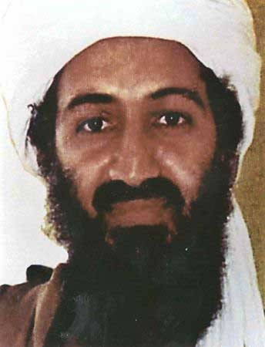
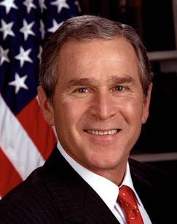
In Mr. Mores movie you will hear about the close business partnership the Bush and bin Laden families have had through out the years. It dates back to before the Afghani-Soviet war. The bin Ladens invested an enormous amount of money in W. Bush’s oil refinery. That is very strange considering Saudi Arabia is the land that already produces the largest amount of oil in the world. Basically you can say that they were just flushing down money.
George W. Bush and

Osama bin Laden
Other investments the bin Laden family did was in the American security. They own about 5% of the entire US just by investing in different banks, companies and also by giving the government, and especially the Bush family, money.

A very odd thing is that after 9/11 George Bush visited his dear friend bin Laden in Saudi Arabia. And this seamed very strange bearing in mind his relative was wanted for the action. And how could the ex president do such controversial thing while his country was in mourning?

Even though the evidence is everywhere it is very hard to prove that all this is actually true. The reason is that lots of the documents that support this theory and has been known to exist, have some how disappeared. And even though the entire world knows that it was W. Bush’s father who contributed with weapons to the al Qaeda in the late 80’s they some how try to forget it and ignore it…

But the fact remains. The ones who supported the al Qaeda most in the beginning financially and made it possible for them to train their “mujahedins were the Bush family together with the bin Ladens.
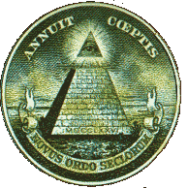

Alternative perpetrators
There are so many other theories to that did this (except for the official one). Some say that it was a prophecy that came true and that it was unpreventable. Other claims that it was the Arabs who did it but they were merely just puppets in a far more sinister plan made up by the free masons. There perhaps as many theories as there are paranoid people, so it would be quite hard to list them all in this document.

Could it have been prevented?
According to a lot of sources, such as the FBI and the Whitehouse it selves, It was known that Osama bin-laden was planning a terrorist attack in the US. In spite of that W. Bush had cut down on the national security funding. His advisers at the federal agency warned him but as it seams he didn’t really listen to what they said.

The Masonic symbol, which can also be seen on the American 1$

Most Americans feel that if the government had kept a better security policy this terrible incident wouldn’t have happened. Up to September 2001 the security, both in international and domestic airports, was rather low considering what a big country US is.

Media
Through out this entire event media has had a great power, not only this event, but also all the time. They are the ones who choose what we are allowed to see and not to see. What we are allowed to think and not to think. The pen is the greatest power tool.

Fow news is a media source that is very subjective. They always support the republicans in every debate or happening. As a world spread media sources it hurts their credibility. Especially since they’ve been caught telling fake news.
It is also known that many leading republicans and relatives to politicians have a strong hold on this new channel.

Though we think that all media is supposed to be objective it’s rarely, or more correct, never completely objective. Pictures and texts and facts are used to show what these media sources think to be the most accurate true and also what they want us to think. In this scenario the media went out and made up all these weird connections from al Qaeda to all Muslims. They basically made the masses believe that all Muslims are suicide bombers and that they are all out to kill. And prove that strengthen this statements is that after 9/11 generally Americans was more sceptic to everything that was Arabic or Muslim. There are quite many statistics that says this.

Advantages of this happening
Many people around the world have used this incident, the destruction and death of thousands, for their own benefits. It’s almost impossible to not see how different people have gained power and wealth since 9/11. For example the UN has lost its ability to interact against wrongdoings when the US on the other hand can more or less do whatever it wants.

Also the EU has gained strength a bit, because now they can refuse permissions more by saying that they suspect someone to be a terrorist. They have gotten some sort of military base in the Middle East by sending their allied troops.

The security agencies have gotten more clients. Even though there has been terrorism for some time now, it wasn’t until 9/11 when everyone really began to worry. And the agencies took advantage of that by selling terror kits, boxes with the most necessary thing someone could need in case of a terrorist attack.

The war against terrorism
The US government is going on and on about this war against terrorism that the world have to fight against. But what is it? What is it that we are supposed to fight against? Who’s the enemy?

To be able to answer this question you’ll have to know what terrorism is. If you look it up in the Swedish national encyclopaedia, you’ll find that what they consider to be terrorism is, “violent actions directly related to political issues in the society without consideration of the human sacrifices”. So that is what we are supposed to fight, right?

Not really. The thing is that the US government and Fox News don’t want people to know about the political issues part. They want it to seams as the terrorists are the bad guys entirely and that it is Americas right to fight against them with all actions regardless how many civilians gets sacrificed in the battle for peace.

But hold on! Isn’t that also terrorism? Remember “without consideration of the human sacrifices”…

I interpret it to be a war against civilians indirectly. Civilians around the globe who are sick of the way the world is being controlled and therefore see no other way then to violently get their voice heard.

How ever, I do not support these actions in anyway! It is wrong and goes against all moral. But I do understand those who are so desperate that they feel like they have to do things such as the 9/11 incidents. When their governments and their suppressors don’t listen to what they have to say and how they feel, they don’t really have any other choice.
And if the American government wants an end for terrorism they should begin with their own country before attacking others. Just look at the KKK, CIA, the new Nazi organisations etc…

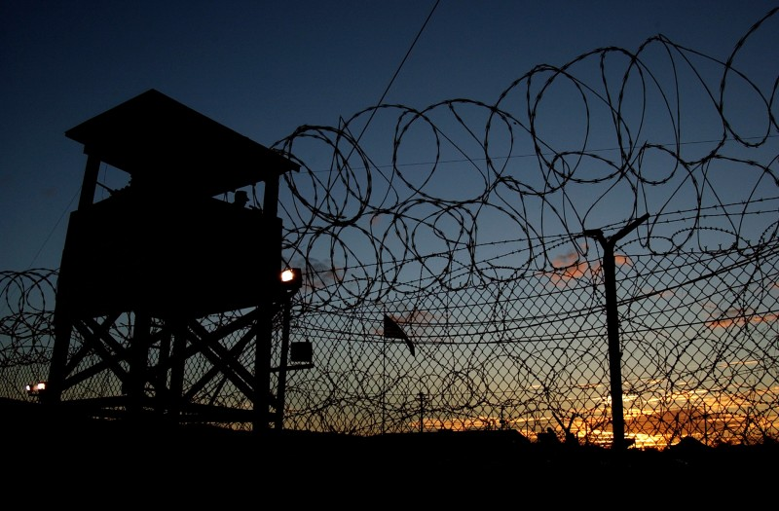
Combatant
A new term that the American government made up so that they could take prisoners and do what they wanted to them. If they had called them civilians, they would have been forced to give them a faire trial. On the other hand, they couldn’t call them prisoners of war, because then they would have been required to follow the UN rules about how to treat prisoners of war. So they made up the cunning word combatants, neither civilian nor prisoners of war. This way they could make up their own laws and rules about how to treat the combatants. And that’s precisely what they did.

The fort on Guantanamo Bay
First of all they made sure of that they had a place to keep their prisoners. After a while of thinking they come to think about Guantanamo bay. And so they began to send all their prisoners and suspected terrorists to the American occupied fort on the Cuban island.

Not many countries reacted on the wrongdoings that America was pulling off. What could they say really? The world still felt sorry for the Americans and their great loss. There also was, and still is, a fear of the US government.

The US government haven’t yet given the combatants a fair trial even though the UN has demanded them to either do that or give them back to their countries.

Different Organisations
There are so many different sort of organisations on our planet such as Greenpeace, Amnesty, WHO. Then we also have the terrorist organisations such as IRA, ETA and of course, the most famous terrorist organization of our time, Al Qaeda.

Al Qaeda
This terrorist organisation is at the moment the most well known because of the media coverage. It was formed in the late 80’s when Afghanistan was in war with the Soviet. The name “al-Qaeda” means “teaching” or “book” and the word is of course Arabic.

In their early years they were allied with the Americans who financially supported them and supplied them the newest weapons of that time. The Americans saw them as heroes, freedom fighters, and righteous men.

After the war ended, also when the cold war was more or less over, things changed. A conflict of interests arises between this organisation and the US government. Al Qaeda wanted the US out of Afghanistan, but the government had other plans.
The Taliban’s wanted to establish a completely Muslim regime that would fallow the sahaaria.

The leading al Qaeda members have not taken responsibility for the 9/11 incident, but they have praised the once who did it.

Facts about Al Qaeda

Classification: Religious

Date formed: Late 80’s
Last attack : June 20, 2004
Strength: Approximately 50,000 members
Key leaders: Mohammed Atef,
Amjad Hussain Faoogi, Khalid Sheikh Mohammed.
Fatalities: 3578
Injured: 6401

www.tkb.org

The motives that al Qaeda might have are many.
One of them is that the Americans wanted control over the Middle East countries and take their oil resources. They also stood, and still stand, on the Israelites side, which makes them a direct enemy to all Muslims. They ‘tricked’ al Qaeda to win against the Soviet so that the US would gain power in the world. Moreover they made bases in the Muslims holiest country, Saudi Arabia. These are only some of the motives that the al Qaeda had.

If they did it, they did it because they truly thought it was the right thing to do. I wouldn’t say it was much more different from the medieval crusades. The reason was the same, for God and to get the holy land of Jerusalem. They see them selves as martyrs and not as suicide bombers. Their way of thinking goes way deeper then we can imagine. It’s not like they can wake up one day and just decide to not believe in all that they have been brought up with. They did it because that was what they had been thought. I mean some people are brought up to hate Israel and America just as we are thought to dislike Nazis. What I’m trying to say is that they are brought up to

The truth?
I may sound cynical but I doubt that the real truth, the entire truth will ever be known to the world. Different people see the truth in different ways and usually they like to believe the “truth” that benefits them.

Also the thing is that the documents that proved that any of the mentioned theories were true contra false will probably be gone at the time when they are supposed to come out public. That’s just the way it is with all the governments around the globe. For one reason or another they want some things to be keep from the public. Most likely so they’ll have more power over the masses. So my opinion is that because of the human’s lust of power, we’ll never entirely know what happened. It’s just sad that people just trust the media completely and don’t reflect more on what happened, much is lost that way.

Sources
http://www.infoplease.com/
An American searching tool, kind of like the Swedish NE.se – the good thing is that this is totally FREE. It has lots of American history and also world history, the down side is that it’s kind of pro American and not very subjective. But at the same time it’s relatively objective considering how patriotic American sites are.

http://www.ne.se
The Swedish national encyclopaedia. I like this source because it is the most objective site I know. I mean just look at the language, so dry without any feeling what so ever. Just plain facts...

http://www.michaelmoore.com

http://www.patriotsaints.com

http://library.albany.edu/reference/terror.html
This is probably the best site to find 9/11 sources. This site has a complete list of the most relevant and accurate sites according to the university of Albany.

http://www.tkb.org/
This is a very good site with all the facts about all the known terrorist organisations in the world.
The bad thing is that according to these people lots of Muslim charity organizations are terrorist groups.

http://www.whitehouse.gov/
This is the official site for the American government. You can find all

http://www.conspiracyarchive.com
Here you have all the greatest conspiracies gathered on one single site. It’s like heaven for all paranoid people like myself. So much to learn but so little time... There are many things that you can read about here that you never thought where true. Then again lots of them aren’t…

