Homelessness

What would you do if you one day have to move out to the street?
How would you feel if you didn’t know if you would get anything to eat today?
And if you didn’t have any money to buy food or clothes?
I know.

I’ve pretend to be homeless in a couple of months and I have experience the feeling of having no place to sleep and no place to call “Home”.
It started when I were going to write an article about homelessness when I got the idea to try living as a homeless. My friends told me I’m crazy, ‘cause I want to be a homeless. But I was settled on my idea.
The day came and I went out on the street and met a really nice guy, named Link. He said he had lived out on the street for a while and we talked about lots of things. We started to hang out together, he was also alone because his friend was going to meet his other friends somewhere and Link couldn’t follow. Link and I started to beg for money. It was an awful feeling to go to people and ask them if they got any money to give to you. Many people said No or just acted like if I didn’t resist. It was hard to realize but in someway you don’t care because you have to get some money so you can get something to eat. If you don’t have anything to eat, you’ll die.
When the nights came I went very scared because you knew that you didn’t have any home or something. You must sleep out on the streets somewhere and I was scared because I couldn’t lock a door behind you so you could feel safe.
There is a place called Captain Hook where you can sleep if you’re a homeless. It’s some kind of floating doss-house. I think it’s kind of cheap to stay there for a night only three quid for one person. Then you got a dry sleep, safety from crazies and so on.
Link and I started to live on the streets together. We had very fun in some moments and sometimes it wasn’t so fun either.
The last week I was going to live on the street, Link and I caught a serial killer. I was so scared when I noticed that Link didn’t come out from the house. I thought that the killer also called Shelter had killed Link but he was alive!
When the police had came to take Shelter to the prison, I told Link who I really was and what I have done and everything. I also gave him a wad of banknotes. He went upset, angry and sad at the same time. I didn’t feel so good about lying to him all the time. I don’t feel OK about it now either.

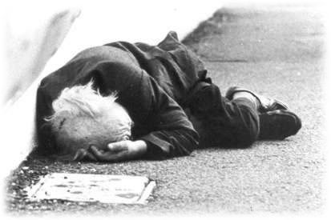

I think that it’s mostly the poor people that end up like homeless. Because their relatives aren’t so rich either, so they couldn’t get any help from them. If you are rich it must be harder to get homeless, because then you got your relatives that mostly also got much money. Well, everybody can be homeless. It’s not so difficult.

Why people get homeless can depend on many things. Your parent’s are maybe dead and you have no relative that wants to take care of you so you end up on the street.
Maybe you have been fired from you’re job and now you don’t have the money to pay the rent so you have to move, but you don’t got any money to buy an apartment either so you end up on the street.

