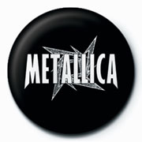
By: Joakim Lindqvist

My favorite rock group is Metallica. They play trash / speed metal and released their first CD, “Kill ‘em all”, in 1983. Metallica have four members, James Hetfield, Kirk Hammett, Lars Ulrich and Robert Trujillo.
James Hetfield is from Los Angeles in California. He has got blue eyes, brown hair, is 1.85 meters tall and was born on the 3rd of August in 1963. He is married and has three children. In the band, he plays the guitar and sings. He is the “front man” in Metallica.
Kirk Hammett is also a guitarist but he also sings in the background in some songs. He was born on the 18th of November in 1962 in San Francisco. He’s married, has got brown hair and eyes, is 1.75 meters tall and is a big fan of Jimi Hendrix, Led Zeppelin and UFO. He joined the band in April 1983. He says that he plays guitar at least 361 days a year.
Lars Ulrich is the drummer in the band. When he was 13, his grandmother bought him his first drum kit and when he was 19, he called James Hetfield and asked if he would start a band with him. Lars is married to Skylar and they have two children. He was born on the 26th of December in 1963 in the Danish town Gentofte. He’s got green eyes, has blonde/brown hair and is 1.70 meters tall. He started early to listen to Deep Purple and other “classic” rock bands.
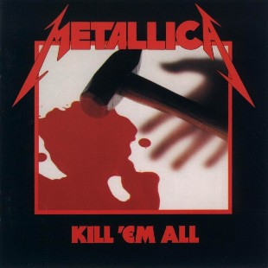
The fourth member is Robert Trujillo. He plays the bass guitar and he is the newest band member. He was born on the 23rd of October in 1964, has brown eyes and dark hair and is 1.75 meters tall. Before Metallica, he played with Ozzy Osbourne.
I like Metallica because of the rhythm in the songs and the good mix of all instruments they play.

Kill ‘em all, Metallica’s first album.

