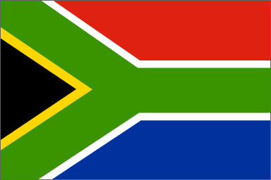

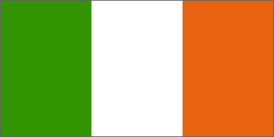
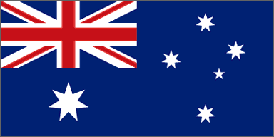

The topic for this paper is to compare three English speaking countries school and education systems. Since this topic is very large I have chosen to focus my investigation on the elementary school system. The countries that I have selected are South Africa, Australia and Ireland. The reason why I have selected these countries is because they represent three different continents. I thought it would be interesting to see how big the differences are. Since South Africa offers the biggest difference from what I’m used to, I have decided to write a bit more in detail about that country. I hope that you will find this paper as interesting to read as I thought it was to write and work with.

South Africa – education
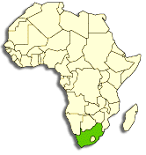
During the apartheid system there were separate schools for white, coloured, Asian people and black people. In 1991 governmental schools for students of all races were opened and in 1995 the apartheid was officially abandoned in the governmental elementary school. At the same time it became free of charges and compulsory for all children between 7 and 16 years of age. However, the shortage of qualified teachers as well as facilities and books is big.
Even if a great number of the children start school when they are six, they don’t always continue after the sixth grade and even less continue through the four last years of the compulsory school. Mainly black boys leave school too early, sometimes without learning to read and write. About seven million grown up people can’t read or write.
During the apartheid system, school was compulsory for white, coloured and children from India but not for the black children. The school system from 1953 aimed at giving the black people a lower education so that they only could be employed on the low salary jobs. During the 1960’s and 1970’s ten times as much money was spent on a white student as on a black.
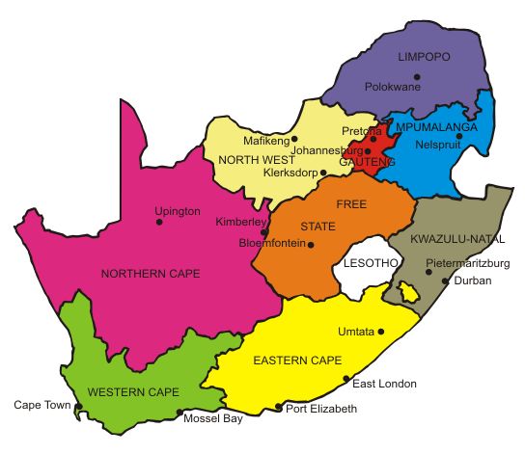
From the time of the so called Soweto riot in 1976, the schools for the black students became centres for growing protests against the unfair school system and against apartheid in general. Chaos ruled in many schools in the poor areas and for longer periods there was no teaching at all. Even after the apartheid system was removed in the 1990’s, many black children did not attend school, and even nowadays there are fewer black young people graduating from upper school than what was the case during the apartheid system.

More than 90% of the budget for education is
spent on salaries and still has the schools
difficulties to find qualified teachers.
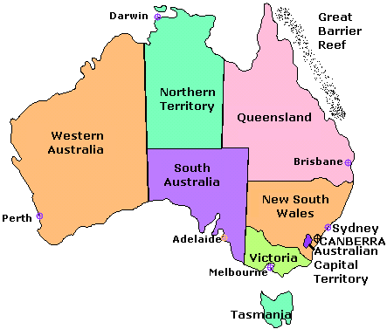
Australia - education
School attendance is compulsory in Australia between the ages of 6 and 15 years (16 years in Tasmania). The governments of the different states are responsible for the schools while the federal government has a co-operative function between the states. For example they try to equalise the differences between the states.
Most children begin in some kind of preparatory schools at the age of five. After six or seven years in the primary school, the children continue at high school where the student in some states can choose special schools with technical, academical or other focuses on the studies. Those who want to continue to upper school have to attend an extra year in high school.
About one third of all children attend private schools, mainly run by the Catholic Church and very often boys and girls separately. I the inner parts of Australia, the children either attend boarding schools or are taught at home via the so called Schools of the Air. In these cases the students are in daily contact with their teacher via radio or computer. Every now and then the teachers visit the students in their homes.
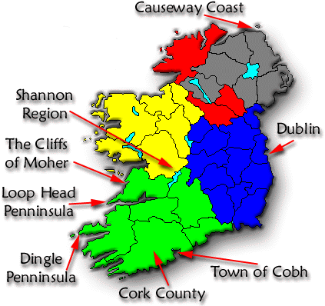

Ireland - education
Ireland has compulsory school between six and fifteen years of age, but a great number of the children start in preparatory school already when they are four. The preparatory schools are a part of the ordinary school. Most schools are private and are run by different religious congregations even though they are mostly financed by state money. Religious education is voluntary. There are big differences concerning level of education between elder and younger people.
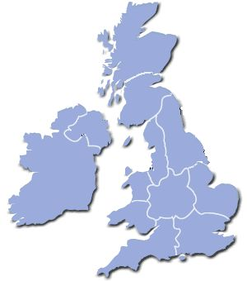
After primary and secondary school,
more than 9 students out of ten
continue to the upper school.

Amount of children starting elementary
school in the year 2000

South Africa 89%
Australia 96%
Ireland 90%

Number of students per teacher
in the year 2000

South Africa 33
Australia 18
Ireland 20

Ability to read and write
in the year 2001

South Africa 85,5%
Australia almost 100%
Ireland almost 100%

When comparing the educational systems in South Africa, Australia and Ireland it is obvious that the differences are very big between South Africa on one hand and Australia and Ireland on the other. The difference between Australia and Ireland is quite small. This has to do with history and the political differences in these countries. Even if Australia has a minority population of aboriginal people it seems that the problems in South Africa are much greater. As late as 1995, the so called apartheid system was officially abandoned. Since then, it has been possible for coloured, Asian and black people to study with the same conditions as the white people. Ireland has never been forced to deal with such problems. Ireland is a rather unified country, dealing more or less only with differences in faith, that is, being catholic or protestant.

When I compared Ireland with Sweden I was quite surprised that most schools in Ireland are private and are run by different religious congregations.

When I compared the different countries I thought of Sweden and I do think that our school system here is quite good. The number of children that start elementary school in South Africa and Ireland is almost the same. But in Australia it is much higher. I think that in Sweden it is probably even higher.
When I compared the number of students in class, meeting one teacher, the difference between Australia and Ireland is quite small and it is similar to the conditions in Sweden. In South Africa the classes are much bigger which probably has to do with the fact that the schools have difficulties to find qualified teachers and also that the country still, in comparison to Australia and Ireland, is poor.

In the more modern countries that Australia and Ireland represents almost all people can read and write. But in South Africa only 85,5% of the children has this ability. Probably this has to do with the history with the apartheid system that forbids, above all, black children to really get a good education. To change a country in just a little bit more than ten years is difficult, and I do think that they still are struggling a lot with these problems.

In all countries it is compulsory for children to go to school between the ages of six or seven until fifteen or sixteen years of age.

I find that the school systems in Australia and Ireland are very close to the schools in Sweden. Everyone can read and write. It would be very interesting to find out how the situation for black children in South Africa will change in the future. It is probably necessary for South Africa that they can solve this, they need their people and it is important that the population is educated, that they can read and write.

The most important reflection for me is that the school in Sweden is very good and offers all of us a very comparable education that makes it possible for us to choose our future education.

Encyclopedia Britannica: http://search.eb.com/

Nationalencyklopedin: http://www.ne.se/

Landguiden: http://www.landguiden.se/

Mindra Ericsson 9:1

