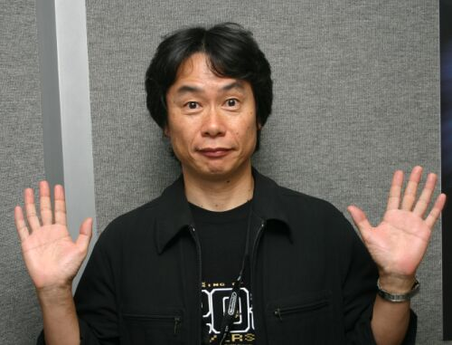
宮本茂
Shigeru Miyamoto
Bild från: http://www.gamasutra.com/features/20040707/SM.jpg
"Video games are bad for you? That's what they said about rock and roll."

Källor:
http://en.wikipedia.org/wiki/Shigeru_Miyamoto
http://www.miyamotoshrine.com/theman/bio/index.shtml

Writer: David Grundström

The 16:th of November in a little japaneese village, Sonobe-cho, a little boy was born.
This boy would grow up to be one of the most knowned and respected videogame Producers, but nobody knew…
As a boy he loved to draw pictures and explore the village surrondings.
One day he found a big hole in the ground, a hole that turned out to be an entering to a gigantic cave system.
And that you can find traces about in his games.
A really good example of such a game is “The Legend of Zelda”, where you need to find eight pieces of a treasure called “the Triforce” in eight different caves to claim the power of “the Triforce” to later go to Ganons Tower wich have an entrance in a cave…

The characters he have created is almost “a guide to videogame classics”.
He have created Mario and Luigi, Donkey Kong, Zelda, Kirby and much more.

As a child he wanted to make anything to astonish to the world, like a painter or puppeteer and in later years he made toys.
He studied “Industrial Design” at the “Kanazawa Munici College of Industrial Arts and Crafts” which he entered in 1970.
It’s said that he only attended class about half the time, which made his stay longer than it should have, in a total of five years.
When he graduated he didn’t want to just take the first best job, he wanted something that he was interested in and 1977 his father contacted a friend of his.
The friends name was Hiroshi Yamauchi, The company was Nintendo.
At that time Shigeru was 24 years old and when he met Yamauchi he asked him for toy ideas. And Miyamoto returned a bag of toys and drawings which made him Nintendo’s first staff artist.
But it wasn’t until 1980 Yamauchi wanted a videogame made.
Miyamoto loved arcades in his College years and said he would love to make such a project. And the game that was made became known as Donkey Kong.
Donkey Kong gave birth to the hero “Jumpman” which later got the name Mario.
And arcade games was just the beginning, he later made the videogame you could take home and play on your television. The console NES(Nintendo Entertainment System) that had Mario Bros. and the soon to follow “The Legend of Zelda”
Shigeru got a bit famous and started to date, and later he married Yasuko that worked in Nintendo’s administration department. And after they married they bought a house near Nintendo so Miyamoto could walk to his work.
Today Shigeru is called the “Spielberg” of Videogames, and have been honoured with many awards and prices.

The End…

