Four days in England
My fly i bought from sas for 4 764 kr and the return flight also 4 764
On my first day i should look att the city and look at some clothes and look at the london eye i think i going to ride with it. The hotel i shall live at is cald the city hotel and its is next to the London tower it Coasts £35.00 itts 85 roms total
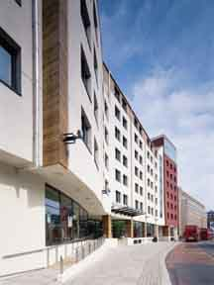 this is a Picture of the Hotel .
On the second day i will start me guided tour that will take threea days
O the first day of the tour we will visit Kensington Palace
Albert Memorial, Albert Hall
South Kensington Museums Knightsbridge, Harrods, Buckingham Palace, St Pauls Cathedral,
Westminister Abbey, Big Ben och Houses of Parliament, The River Thames, The Royal Parks
Trafalgar Square, Piccadilly Circus, Horse Guards Parade, Bank of England, The Guildhall The Tower of London och Kronjuvelerna, Tower Bridge.changing of the guard.

And on the second day we will go on guided shoping tour in London.
We vill visit a lot of o of exclusive stores like cartier, woodhouse.

And on the third day I will do the London blag it is inspired by the movie the Italian job.
I will go around in a mini cooper and do different missions. You shal steal a car and free a guy from a prison and transport a computer terminal and try to break its security system.

On the fourth day I will go for a guided tour with a Harley Davidson and we will look at a lot off stuffs.
Jonas Björnell vallareman.

