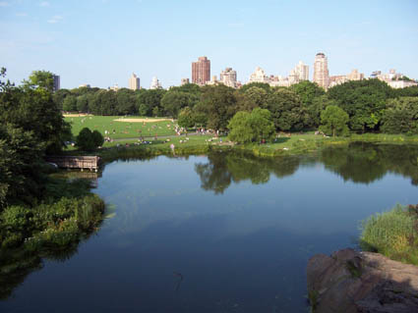



New York City

New York is probably the worlds most beautiful city in the world. Here you can experience many different cultures like in Chinatown with an east Asian influence and culture.
New York is also filled with beautiful skyscrapers and other architectures. You can take a part of USA:s wonderful history in an old museum ore shop around in N.Y.C. You can also eat good in N.Y.C, and after that you can realise yourself at a nightclub.
We mustn’t forget the old and honorful statue of Liberty with will be told more about later I think….
I could continue like this for ever and mentions places like Central park ore Harlem, but lets experience some history.

HISTORY

Before any Europeans ever sat his foot in America the place of New York was inhabited by Indians. When America was discovered in the 15th century people from all the world started to arrive. The area of New York was perfect for grooving and was close to the chore, very fast a city started to grow up. Seinc then the city witch didn’t immediately was called New York has been hurted from many economical crises sense and economical rises. Many different cultures has been gathered in New York such Asians people in Chinatown ore the black people in Harlem. USA has always been in war. First they fought for freedom, then they fought about the black peoples equal rights. After that they fought for trade rights and freedom in Europe.
When that was over they fought for democracy, in the east and now they fight terrorism in east again but the worlds hates them. Well the centre of the freedom fights of America is the New York city with its statue of liberty. When you wisit the proud city of New York you need some advises so that you don’t get lost in the great atmosphere!

http://www.theus50.com/newyork/
http://cityguide-us.com/new-york/new-york/

