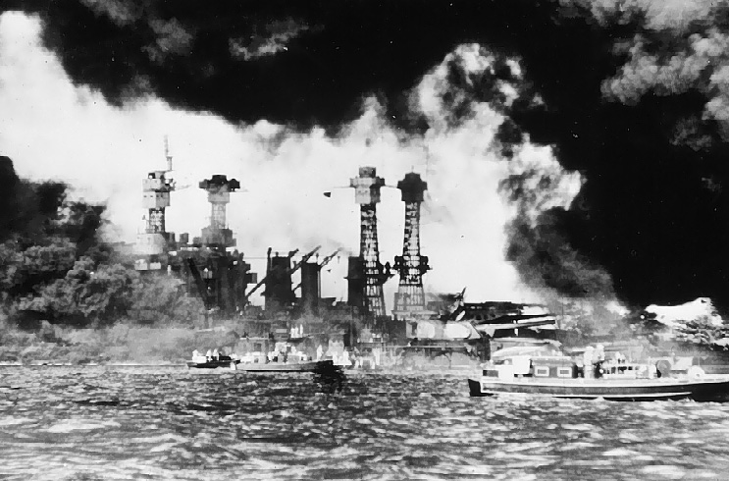
Pearl Harbor
The Attack
On 7 December, 1941 the Japanese attack the American naval base Peal Harbor on Hawaii. The attacks was very carefully planed by Commander Yamamoto Isoroku, he was in charge of the hole Japanese fleet. Their goal was to bring out the American Pacific fleet then the Japanese would be able to concur the whole south Asia whit no problem. Early in the morning exactly 7:53 AM came the first wave, it was sent 44 miles north from Hawaii. Around 240 Japanese Bomb- and Hunting planes were set out in the air by the orders of Vice Admiral Nagumo Chui chi. The planes were heeding towards to Pearl Harbor, American air surveillance noticed the planes on the radar but they were told to ignore them because they were expecting some B-17 Planes at this time from the allies. It was planed by the Japanese and that the attack took place on a Sunday was also a part of the plan because the ships wasn’t fully manned so it made an easy target. The planes wasn’t either ready to start and very few made it up to the air in time. Almost all battleships were destroyed or badly damage. For example Arizona was one of the battle ships that were in port, the ship got its front blown away and an other bomb fell right in to the chimney that led to machine room, it exploded and Arizona sank immediately over 1106 man died and only 405 men could be rescued. In the other attack wave Nagumo sent away 54 bomb planes, 80 planes whit mines and 36 hunting planes from his hangar ship. The second wave was meant to accomplish what the first wave didn’t, the navy facilities on Ford Island, The military bases “Wheeler” and “Hickham” and the base for sea airplanes on Kaneohe. The attack was extremely successfully for the Japanese. America lost 188 planes and 2,403 American servicemen and 68 civilians were killed, and over 1000 wounded and Nagumo only lost 68 Japanese servicemen.
The Recover
But the Japanese didn’t destroy everything, the Pacific Fleet’s three aircraft carriers were not in port at this time. So they got away undamaged, as well oil tank farms and machine shops med it out of the Japanese rage. Because of that the American Pacific Fleet could recover after six months.
The Revenge
The day after (December 8, 1941) USA declared war on Japan followed by the allies. Germany and Italy declares war on USA 11 December. This action by the Japan forced USA into the war. Av: Patryk Mentel Datum: 05-09-17

