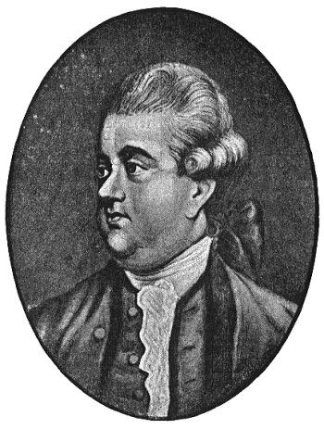
Edward Gibbon

Felicia Svensson von Schreeb Pre IB

Edward Gibbon became the 18th Century greatest, British historian as the author of "The History of the Decline and Fall of the Roman Empire," one of the few historical works of the modern era to stand comparison with the great classical works of Herodotus, Thucydides and Tacitus - both as history and as literature.
Edward’s childhood indected a series of illnesses, and more than once he nearly died. But that didn’t stop him from making history in history itself.
During his education, Gibbon traveled much between France and England. While staying in Rome, Gibbon started writing “The History of the Decline and Fall of the Roman Empire” wich became one of the greatest works of history ever written.
The Decline and Fall of the Roman Empire is perhaps the only Western historical work that is more than one hundred years old and yet continues to be read frequently by the non-specialised educated public. Why is this so? For the Western Man in particular, there is here a unique fascination: for out of the ashes of the Western Roman Empire were born the modern nations of Europe. Consisting of 71 chapters, 2136 paragraphs, some one million and a half words, and close to 8000 footnotes, the Decline and Fall encompasses a millennium and a half of history.

What led first to Rome's decline and ultimately to it’s fall? Gibbon discovered many causes, which he discussed in various parts of his work.
One of the factors was that the romans became to comfortable and started to take things for granted. Two other, and according to Gibbon, most important factors were
1) the invasion of the barbarians, and 2) the growth of Christianity in Europe. Because of their belief within Christianity of a life after this, most Christians had no intention to serve the state and the public good, but instead concentrate on the next world, and their private salvation.

I think that Edward Gibbon seemed to be a very intelligent and logical man. His thoughts about “The Decline and Fall of the Roman Empire” seems very much as the truth to me. He seemed to be well educated and have lots of experiences regarding to his world-known book. The fact that his own life wasn’t as he wanted it to be didn’t stop him to become a famous name in world history. I can also mention that he was the first historian who was read by the “common” people.

What I think Edward Gibbon means by the quotion “History... is indeed little more than the register of the crimes, follies, and misfortunes of mankind.” is that in some way, history itself has formed the modern society. He means that history affects the way people think today, how we feel about certain things and the way the society is built. It’s also a lesson in how to avoid making the same mistake once again.

