A Little fact about Australia!

Commonwealth of Australia is the real name.
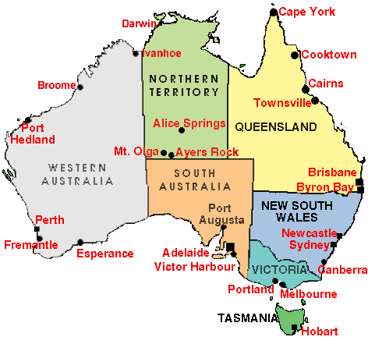
“The lucky country” called Australia but they have many problems too.
It lives about 18 million people on this Island.
The Island is about 7, 7 square meters.
Canberra is the capital and it lives about 311 thousand people there.
Australia is a very big Island.
The continent is south of Indonesian, between Pacific Ocean and Oceania.

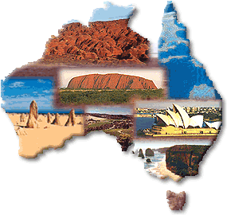
They have people from different countries there 94 % of them are European’s, 4 % are Asiatics and 1, 5 % are aborigines.

The season in Australia is just the opposite of Europe’s and North America’s.
When we have summer they have winter and when they have spring we have autumn.
In the city in Australia they have 14 – 20 degrees centigrade above zero on average.

The famous people as Mel Gibson, Nicole Kidman and many more have lived or are born on this Island.
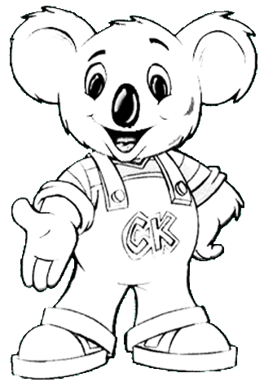
Australia is world famous in cricket, swimming, biking, rugby leage and rugby union, but they have other sports which are football, basketball, Aussie Rules and sailing too.

They have many different animals too, as kangaroo, koala, birds, snakes and many more.
They have over 500 reservations to protect them over the land.

Australia is indwelled in 7 different countries.

Victoria!

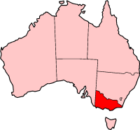
Victoria is Australia's smallest mainland state in area and is situated in the south eastern corner of the continent. According to the Australian Bureau of Statistic’s figures, Victoria's population reached 5,012,700 per cent rise on the previous year.
That is the second most populous of Australia New South Wales, and the most densely populated.

Tasmania!
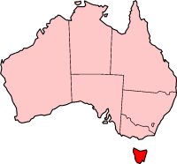
Tasmania is a Island in Australian state and that is located 150 miles south of the eastern portion.
Tasmania has a population of 456,652 and an area of 26 383 square miles.
Tasmania has the nickname Apple Isle due to the large number of apples grown there.
The capital and largest city is Hobart.
The subantarctic Macquarie Island is also under the administration of the state.

South Australia!

South Australia is a state of Australia in the southern central part of the country.
It covers an area of 380 070 square miles.
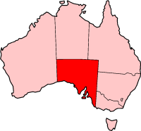
South Australia is known as both the Festival State and the Wine State and its capital is Adelaide.

Western Australia!

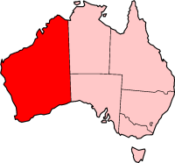
Western Australia is Australia's largest state in Australia.
Covering the western the third of mainland.
It is after Sakha in Russia and the second biggest subnational entity in the world

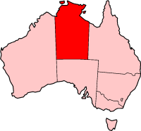
Northern Territory!

The Northern Territory is a federal territory.
The capital city is Darwin.
Residents of the Northern Territory are often known simply as Territorians.

Queensland!

Queensland is a state of Australia in the northeast of the country. That is the second largest state by area.

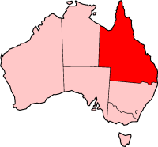
Queensland is also Australia's most decentralised state.
The capital and largest city is Brisbane, but others regional centres include the Gold Coast, Rockhampton, Townsville, Mackay, Cairns, Toowoomba, and Mount Isa. Queensland is often nicknamed the Sunshine State, since a sizable portion of the state is in the tropics.

Queensland was originally a British Crown Colony that was separated from New South Wales in 1859.

New South Wales!

New South Wales is Australia's most populous and oldest state, located in the south-east, north of Victoria and south of Queensland.
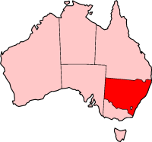
It was founded in 1788 and originally comprised much of the Australian mainland. During the 19th century large areas were successively separated to form the British colonies.

New South Wales is known the world over for the picturesque harbour of its capital, Sydney.

History!

Before 1788 lived 300 thousand aborigines in Australia.
They have lived there over 10 thousand years; they live in Australia now too.
They had not met many European’s, but that coming changed their lives.

1770 discovered the Englishman James Cook the New Holland as name was this time and bruptized that to New South Wales.
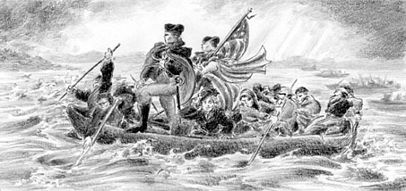
He sailed around the country and he sent a message to the government of England.
The population explosions in the English cities lead that the crimes increased.

After that America’s revolution England more could not send these criminals to the country so they sent them to James Cook’s land as he had discovered.
That was the only solution on the problem.
The criminals came to Australia or New South Wales and could not come back to England.

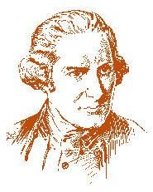
The colonies from England call aborigines to Indian and aborigines were afraid for those peoples.

………………………………………………………..

Aborigines!

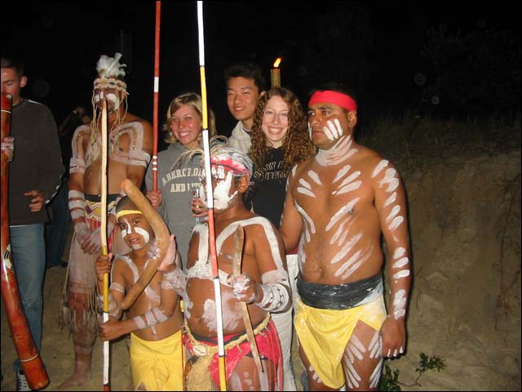
Aborigines are Australia’s people over 40 thousand years.
They think aborigines took a boat to Australia from Southeast Asia across Indonesia.
Aborigines are the oldest people who live today.
When the first European’s came to Australia it lived 500 – 700 thousand aborigines in different groups.

The women picked nuts, berries, took care of home, and they hunted small animals.
The men they hunted and were fishing.
They lived in huts and they had not animals and they had weapons self made like boomerang and many different weapons.
They lived about 20 – 50 people in each tribe.
It was 200 different languages that the aborigines spoke.
They have different dialects too and they moved from place to place.
The Aborigines, they lived or live in Australia today.
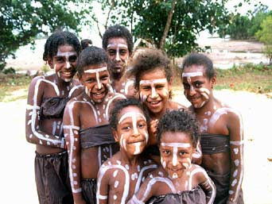
The aborigine’s begin in a poetical work was “when you cut in a tree so cut you in mine veins, when you bore in a rock so bore you in my rib”.
That means the dreamtime is a concept as about of how universal, the earth, the people, the animals and nature creation. But that it’s from tribe to tribe or from region to region.
The dreamtime is not over because is long time ago to the future.

Kangaroo!

The name kangaroo come from colonists who came to Australia.
Kangaroo is a marsupial.
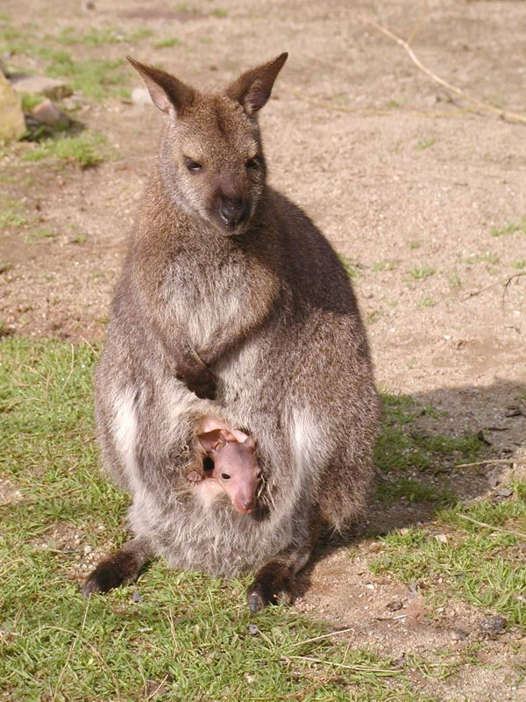
That is about 45 different arts of kangaroo and they are night animals.
The kangaroo can live in a group with other kangaroos or alone.

The Latin name is Macropus robustus and they can be about 1, 5 metres and weigh about 70 kilo
They can be 25 years old.

Kangaroo eat a lot of many different wild flowers and other vegetable fibres so they can jump.
They can jump about 12 metres high and to 80 kilometres fast in an hour.
When they become get pairs it will be a very big war between the males.
When the kangaroo kid has born it is about 1 centimetre and must fin its way to its mothers pouch there it can drink milk so it can be a big kangaroo.
When they are 8 months can they go them selves but they can sometimes jump in to the pouch when they are afraid or tired.
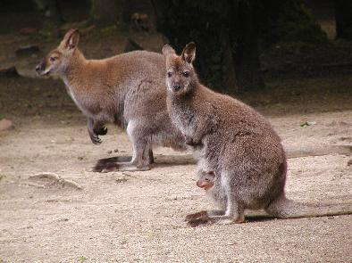

Koala!

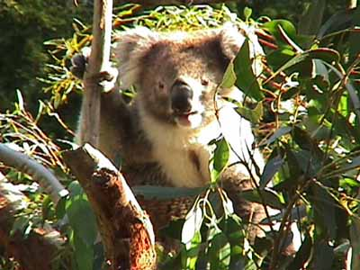
Koala is a marsupial.
That is about a lot of different arts in the koala families and they are night animals.
The koala lives alone in a three.

The Latin name is Phascolarctos cinereous and they can be about 60 - 85 centimetres and weigh about 7 - 12 kilos.
They can be 13 - 18 years old.
Koalas eat much eucalyptus leaves and live in east and South Australia.

Koala’s kid is 2 centimetres when it is born it climbs to this mothers pouch there it can drink milk so it can be a big koala, same as kangaroo’s kids.
When they are 6 months they look out from the pouch and when they begin to climb so can they ride on their mother’s back.

The koala is protected after all hunts.
They hunt because they want the coats.

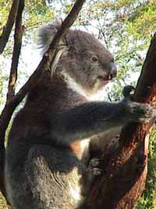

The Great Barrier Reef!
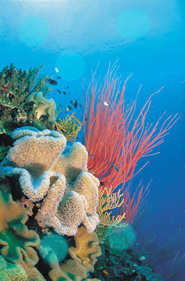
The Great Barrier Reef is the world's largest coral reef.
The reef is located in the Coral Sea the coast of Queensland in north-east Australia.
It stretches over 2000 kilometres in length and can be seen from space.
An ancient barrier reef similar to the Great Barrier Reef can be found in The Kimberlies.
The Great Barrier Reef is the best place for snorkelling or diving.

The Great Barrier Reef is a nature’s miracle.
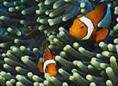
That begin north of Fraser Island and it’s over 2000 kilometres north to Papa New Guinea.

The new coral reef begins to take form for 15 thousand years ago.
That is the world biggest reef.
Those are 400 different arts on this reef and about 1500 different fishes.

Ayers Rock!

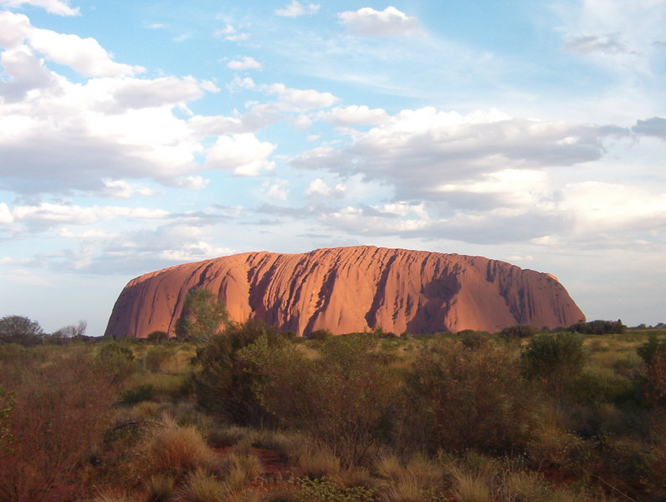
Uluru, otherwise known as Ayers Rock, is a large sandstone rock formation in central Australia, in the Northern Territory.
It is located in Uluru-Kata Tjuta National Park, 350 km southwest of Alice Springs.
Uluru is sacred to the Aborigines and has many varied springs, waterholes and rock caves.

Australian English!
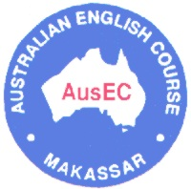
People in Australia speak English too, but they speak Australian English.
Australian English mixed sometimes word and that can be difficult to understand them.

The can say “she’s a stinker today” can they mean “it’s extremley hot today”.

There are many differens between British and Australian English.

Example:

Australian English! British English!

Arvo Afternoon
Aussie Australian
Bushranger Criminal
Chalkie Teacher
Dongo Worthless person
Gummy a sheep which has lost
All its teeth
Never-never Remote desert country
Pom, pommy Englishman
Roo Kangaroo
Tucker Food
Vegies Vegetables

Made by: Sabina Öhgren
Långseleskola HT-05 9B

