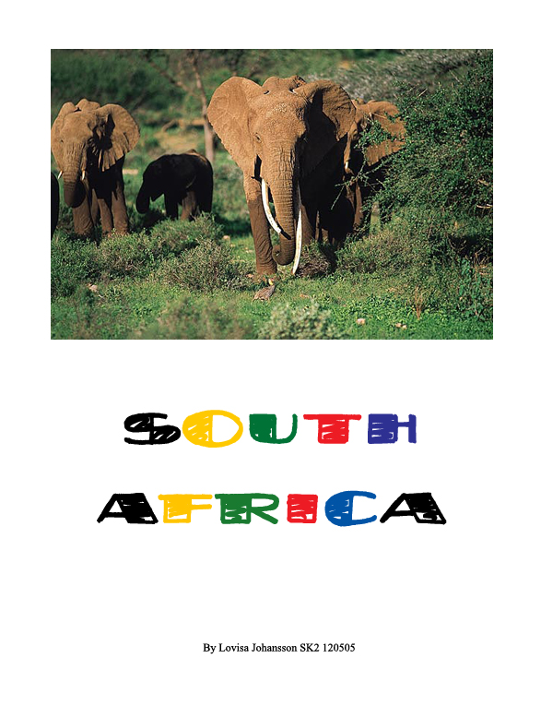

Contents

- Facts – page 3
- Flag – page 3
- Landscape – page 4
- Black and White – page 4
- Education – page 5
- Language– page 5

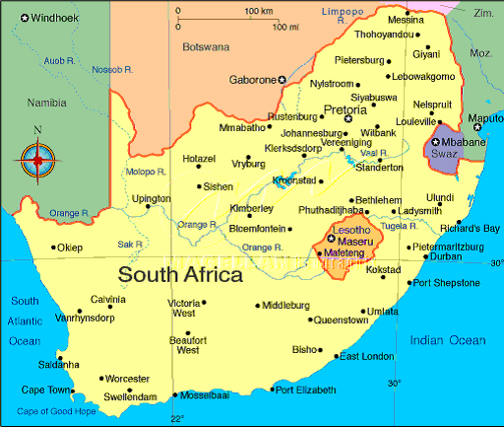

Sources: Nationalencyklopedin
AFRICA – the book
South Africa – the book
www.cia.org
www.info.gov.za
Pictures from Google

Constitution: Republic
President: Nelson Mandela

Area: 1.223.200 sq. km

Capital: Pretoria
Populations: 45.1 Millions
Religion: Christians 68 %, native 32 %
Language: 11 official. Zulu 23%, English, Africans.

Highest Mountain: Injasuti 3408 m
Largest River: OranjeRiver

Largest Lake: Lake Fundudzi

Currency: 1 Rand. 1 Rand = 3.6$
Suffrage: 18 years old

Literary: 81,8% (over age of 15)
National day: May 31

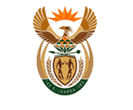
South African coat of arms

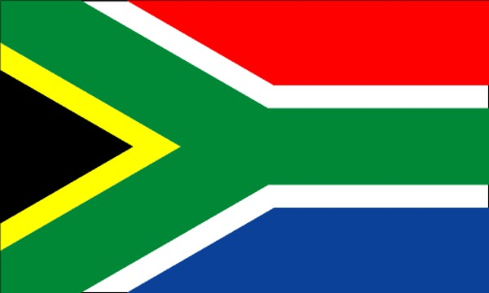
Green, Yellow and black is the ANC’s colour (Africa’s National Congress)
And the PAC’s (Pan African Congress) Red blue and white is from the old Dutch flag and also from the British.

Landscape

South Africa is the tip of the African Continent. The water outside of South Africa is the most dangerous water in the world, where two ocean meets, the Atlantic and the Indian.
South Africa bordered by Mozambique, Zimbabwe, Botswana, Namibia and inside its borders lies Swaziland and Lesotho.
South Africa has a very variety geographic regions whit huge mountain ranges, barren desserts, plateau’s, rich farmlands and great forests.
The highest mountain is Champagne Castle 3.375 m.
The Northwest has a small precipitation and covers whit deserts, the biggest is Kalahari Desert, but only a small part lies in South Africa.

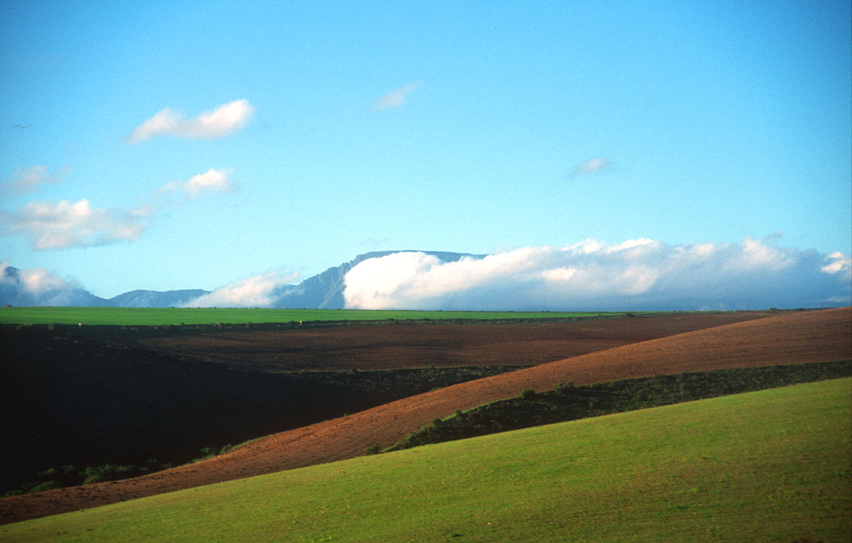
South Africa has a world-wide landscape.

Black and white

1948 the black had cheap labour, bad houses and the black were pushed away by the white, even though the white represent a minority. Thanks to the modern weapon the white could take the power by force and 1948 Apartheid was enforced. The black forced to obey the white laws and in the end 87 % of the lands belonged to the white.
A huge protest where held all over the country against unfair treatment and the government respond was brutal, blacks were killed tortured and thrown in prison meanwhile the rest of the world where outrage.
The black demonstrators tried to make resistance but the government responded whit even more brutal measures.
Not until February 2 1990 the South African president announced that all political prisoners including ANC leader Nelson Mandela should set free. During the next four years South Africa made history whit one the swiftest translation ever, and 1994 the first democratic government ever was elected and as Nelson Mandela as there president.

Education

At 1980’s only 20 % of the black children attended classes.
All white where required to attend school between the age of 7-16.
98% of the White can read and write but only 50% of the black.
The black students had a poor education level there 80 % of the black school had no electricity for light or heat.
1992 the new government improved these schools and upgraded the standard of the black schools and all had to attend classes no matter your race.
The students must be teach in one of the 11 official language and are required to study English.
The government also started a program called RDP (Reconstruction and Development Program) which meant that adults no matter there race would be able to go to school to learn to read and write, which before had been denied.

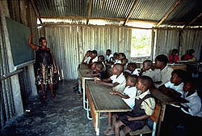
A small country school.

Language

South Africa had previous two official language, English and Afrikaans.
The new law 1994 more official language where added.
Afrikaans who develop from the Dutch who 5 millions have as Afrikaans there mother tongue.
Two millions have English as there mother tongue which is most spoken in the west part of the country.
Zulu whit 8 million people as its mother tongue is the biggest language in South Africa.

