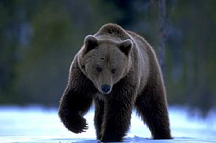
Brown bear (Ursus Arctus)
The brown bear is just one of eight kinds of bear in the world, but they are the same big family.

Appearance: A big animal with round shapes, big head and a sloping back, the paws are big and wide, their tail is short, its ears are round and they have a hump over the shoulders, which is a muscle mass they use when they are digging. They usually are between 100 to 280 cm long, and they weight between 60 to 100 kg (females) and 100-200 kg (males).
Their colour shifts between light brown to almost black.

Food: The bear eats almost anything, ants, berries, vegetables, carcass and big animals like moose and reindeer.

Hibernation: The bear goes into hibernation, but is waken easily, in the winter and survives on its fat reserve, the respiration goes down and so does the body temperature. The hibernation starts, in Sweden, in october-november and ends in mars-april. It takes many weeks to get into the hibernation.
During the hibernation period the bear give birth to 1 to 4 cubs. The kids follow their mother from one to two years. Mother bear only give birth to babies once every other year and it takes four years from the birth to get sexual mature. During the late spring is the mating season.

Distribution: In Sweden they live in Värmland and up to Lapland. They also live in Northern America, Europe and Asia.
They probably came to Scandinavia during the ice age, 12-15000 years ago.
Most of the bears live inside a area that is called the “home ground”, the area is a place where they spend their life and meats other bears, and it’s not like a territory where you defend the area against other individuals.

