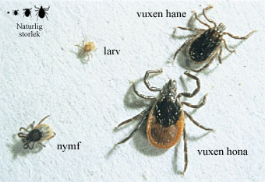
Tick
Is a small animal, and belongs to the spider family.

Appearance: It looks like a spider and is related to mites. The females is black and orange and the male is only black.
They have no eyes, but they can feel our movements, carbon dioxide or smells. A grown up Tick is 2-3 mm. It lives for 2-3 years.

Distribution: The Tick lives in the southern part of Sweden and in the eastern and middle Europe.

The Tick develops in three steps, from a grub to a nymph and then to a grown up Tick.
And it needs blood to develop from one step to another and to be able to pass the winter.

It lives in the deciduous forest and likes when it is thick undergrowth. They need a temperature of + 5 degrease to survive.
The perfect hunting position is on a grass straw, there can the Tick wait for the next animal or sometimes human to walk by. When the Tick have you in its claws, they can feed on you for a week before it develops to the next step and if it is a big female it can give birth to two thousand babies. And after that she dies.

When you are bitten by a Tick you can catch different kinds of diseases, but not if you only are bitten once.

Experience: It does not hurt if a Tick bite you, the only effect I have ever had i that it scratch like crazy after you have removed the Tick.

