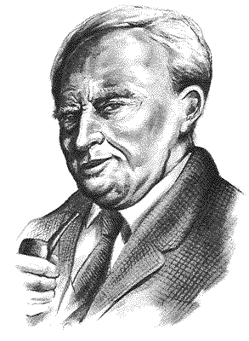

This is about J.R.R Tolkien. His real name is John Ronald Reuel Tolkien. He’s been writing a lot of books.
I’m going to write about he’s most famous books, the lord of the rings. I begin with a list of the books:

The Lord of the Rings

1. The Fellowship of the Ring 1959

2. The two Towers 1960

3. The Return of the King 1961

What is doing J.r.r Tolkien so interesting?

Maybe he’s desk work, he writes everything so detailed, you can even think you are in the book. The lord of the rings is one of the most famous fantasy-books in the world.

John Reuel Tolkien was born 1892 in Bloomfontein in South Africa. When he was 4 years old, he moved to Birmingham in England because his father died young 1896. Even his mother died young, and after hers dead 1904 John been send to a boarding school. He shoved to be very good in school, so he got a scholarship to Oxford, the best school in England. He shoved a big interest in old languages. Which he got a big help in his later books. Year 1816 he got married with Edith Bratt and soon they got a little child together they baptised to Christopher. John kept going in Oxford into year 1817 when the First World War was started he was called to the army. His time in the army wasn’t so long, because he got afraid of being in a mass grave, and came to a hospital. It was under the time in the military hospital he began to write his first lines in his first fantasy literature. When he came back from the war he began in “the oxford Dictionary” group. The work with the dictionary took his time for a few years. In spring 1920 John got asked if could read something he writes for “the Essey Club” on Exeter College. He chose the first history he writes about the world middle-earth: “Gondollins fall” a story about how the beautiful Alf-city falls for the evil god Morgoroths hordes.
First he began to write the children story “The hobbit” which he was going to maintain his children with. Year 1937 it came to the book shops as his first fantasy-book. Soon the book got so popular that he began to write on the book that later was going to do he famous all over the world. The lord of the rings. But the readers must wait cause, he didn’t had much time to write, his work and the family did so he didn’t had much time for the writing. 17 years later after “The hobbit” release his first book from The lord of the rings came to the book-shops. The fellowship of the ring. The first part in the almost 1200 pages trilogy. The year later his next book came to the book-shop. The two towers, and the next year after that his third and last book came to the book-shops. The return of the king. Almost all reviewers was united, this was one of the biggest fantasy-books in the 1900 century. It didn’t take a long time before the English edition was ended. A Tolkien fever was spread in England, or as a journalist described it: The English-speaking world was parted in two camps. They who had read “The lord of the rings” and they who was going to read it.

1959 Tolkien gone in pension just as his books was translated in a large amount of others languages, like Swedish. John Superintended the translating and no foreign book can be giving out without his permission. Even the Swedish translator Åke Ohlmarks got to feel on Johns stubborn. He got to fight so even his own translated city and person-names can be known. When John died year 1973 as 81 years old, he got sludge by millions of peoples all over the world as “The biggest writer in our time”.

The text is taken from the Swedish website “ http://www.algonet.se/~t-sundin/jrr.htm “

