Tunisia

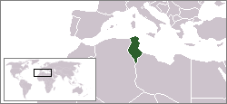

Tunisia is a country in the North Africa. The country
border to Algeria, to the west, and Libya, to the
southeast. And bordering the Mediterranean Sea
The population in Tunisia is ten million, Tunisia is
ranked on the 80th place in the world’s population.

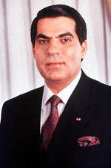
The president of Tunisia is “Zine El Abidine Ben Ali”. He
was born September 3 1936 in France. He have been president
since November 7 1987, he have been president in 19
years.
When Zine was young, he was in the France military.
The people in Tunisia like him, the last voting he get 95% of
the votes!

Short facts
Climate: Temperate in north with mild, rainy winters and hot, dry summers; desert in south.

Age structure: 25, 3 % is between 0-14 years old.
68, 1 % is between 15-64 years old.
6, 6 & is 65 years and older.

Religion: Muslim 98%, Christian 1%, Jewish and other 1%.

National day: 20 Mars, because Tunisia independence from France that day, 1956.

Airports: 7, Tunisia’s head airport is “Tunis Carthage International Airport”

Tunisia is very good at many sports, most handball. The country had the World championship 2005 in handball. It was a very good tournament and Tunisia came on the third place!
They are also good at football

